**MAKEMYTRIP.COM**

* **Tables in the dataset.**

1. **Hotel_data**
2. **City_data**
3. **State_data**
4. **Transport_data**

**DATABASE MODEL :-**

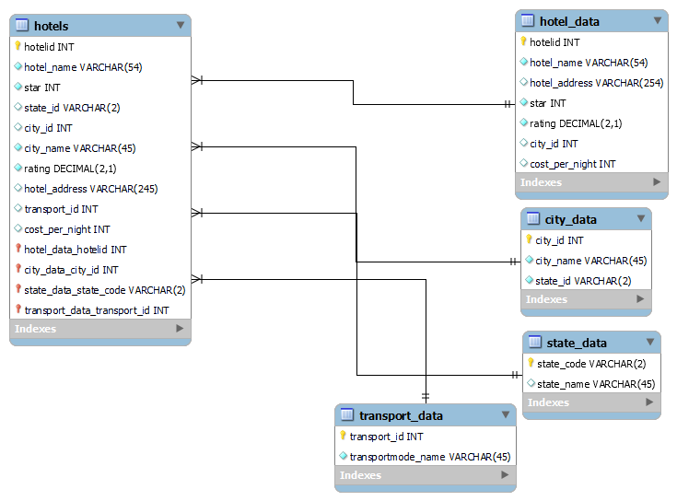

**TRIGGERS**

**A trigger in MySQL is a set of SQL statements that reside in a system catalog. It is a special type of stored procedure that is invoked automatically in response to an event. Each trigger is associated with a table, which is activated on any DML statement such as INSERT, UPDATE, or DELETE.**

**1.hotel_data**

* hotel_data_BEFORE_INSERT

**2.city_data**

* city_data_BEFORE_INSERT

**3.trasport_data**

* transport_data_BEFORE_INSERT

**4.state_data**

* state_BEFORE_INSERT

**STORED PROCEDURES**

**MySQL Stored Procedure. A procedure (often called a stored procedure) is a collection of pre-compiled SQL statements stored inside the database. It is a subroutine or a subprogram in the regular computing language. A procedure always contains a name, parameter lists, and SQL statements**

* costliest_hotel_over_metro_cities_with_rating_below_3

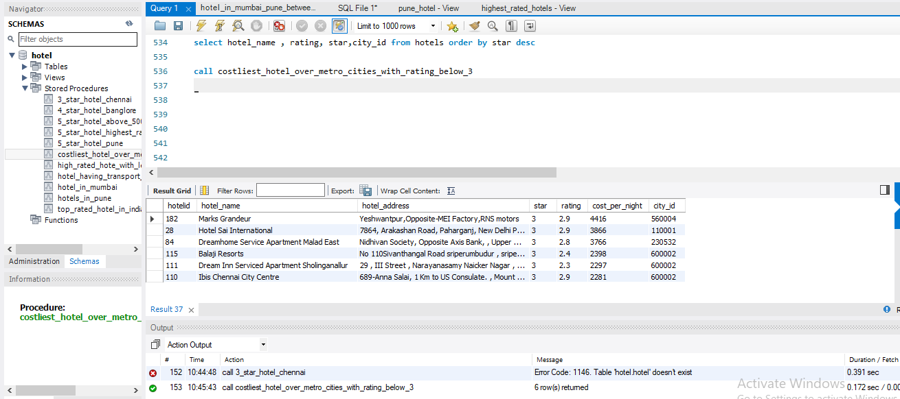

* top_rated_hotel_in_india

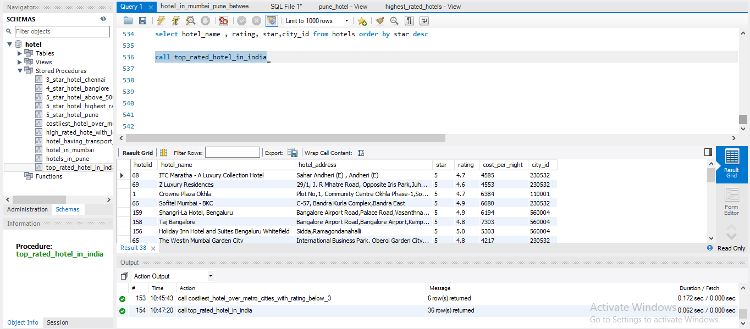

* hotels_in_pune

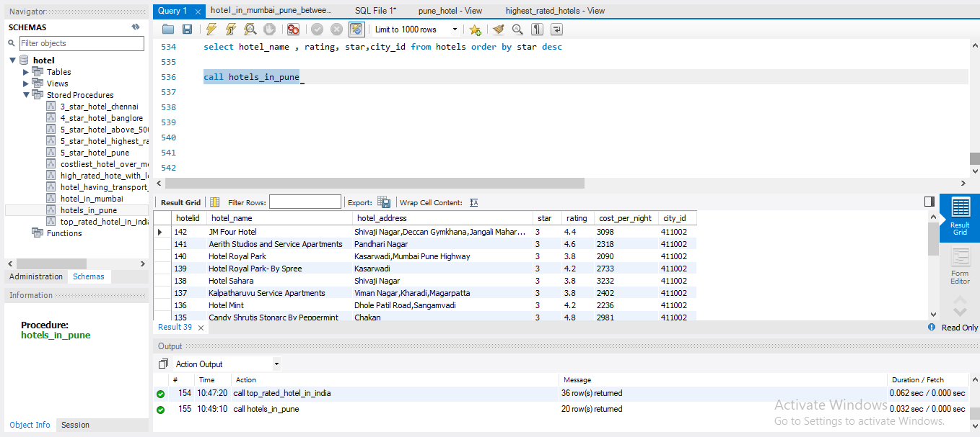

* 5_star_hotel_above_5000_cost

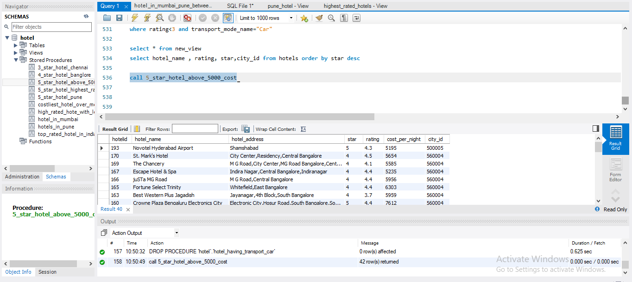

* 4_star_hotel_banglore

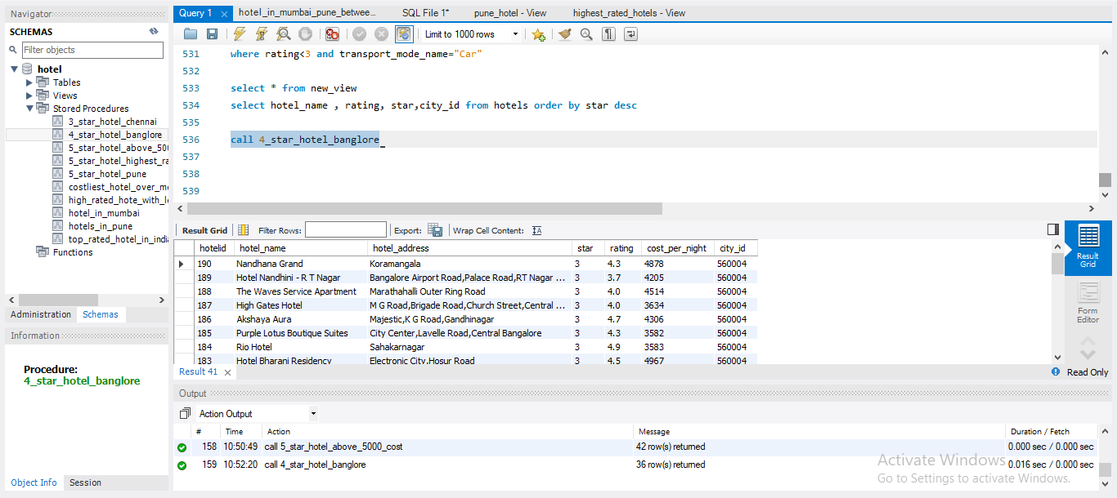

* 5_star_hotel_highest_rating_among_metrocities

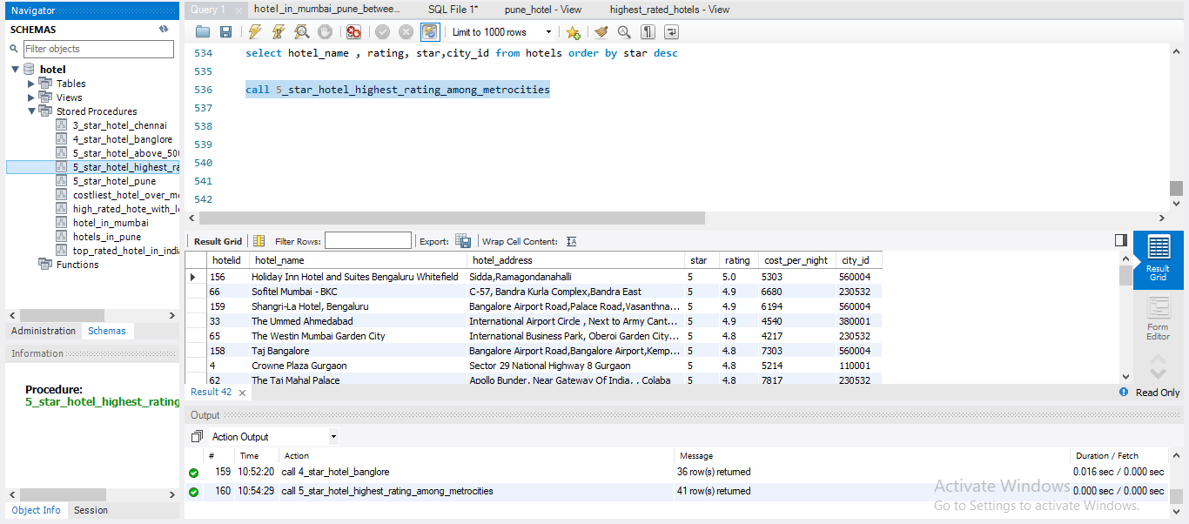

* high_rated_hote_with_less_cost

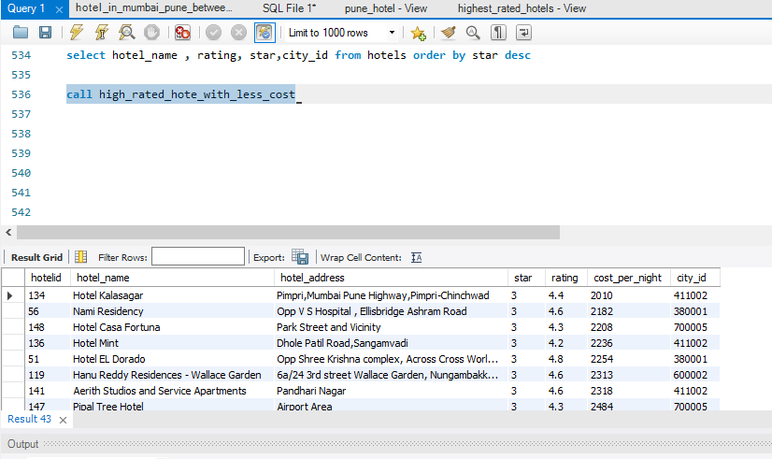

* hotel_in_mumbai

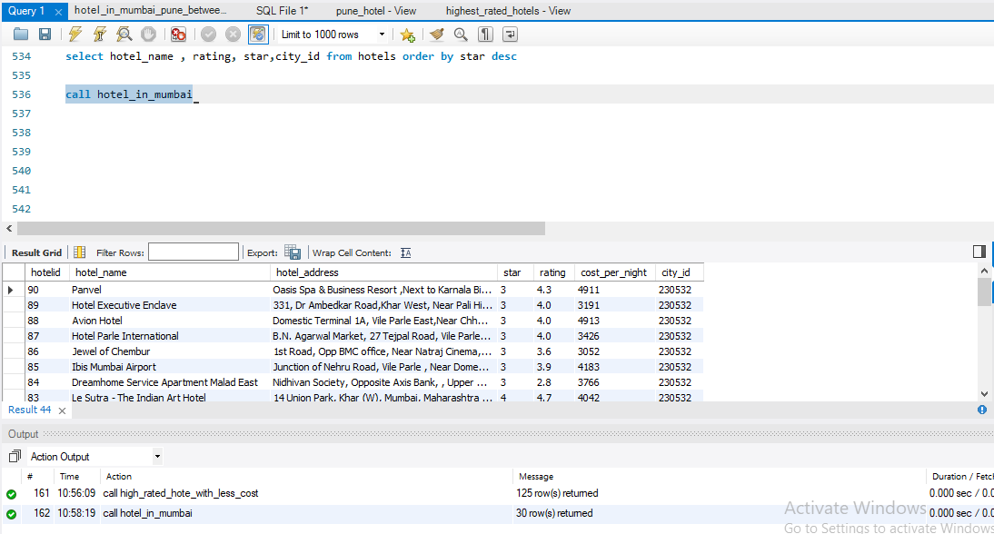

**View**

**A view is a database object that has no values. Its contents are based on the base table. It contains rows and columns similar to the real table. In MySQL, the View is a virtual table created by a query by joining one or more tables.**

* highest_rated_hotels

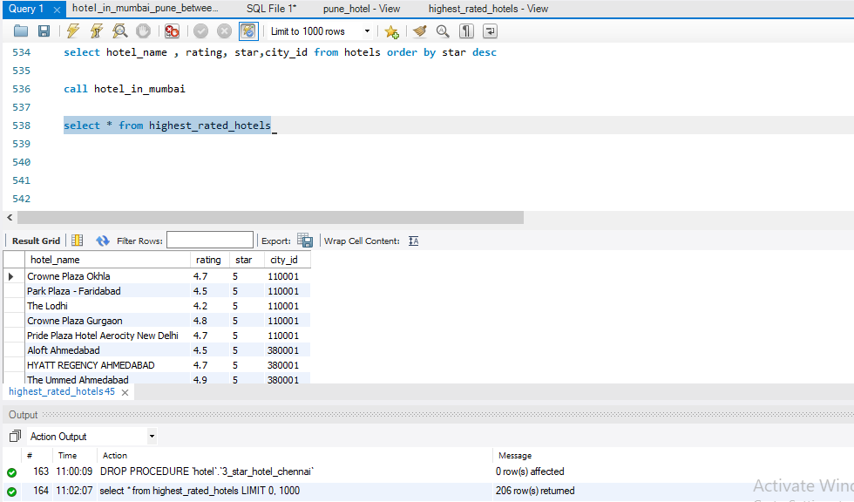

* pune_hotel

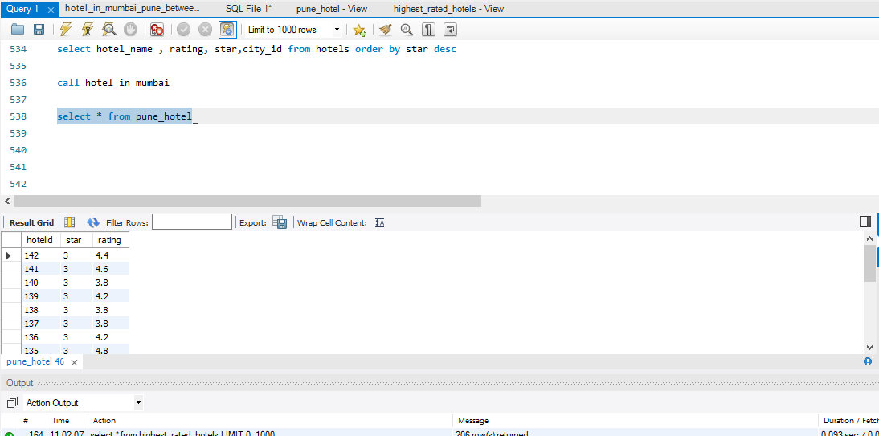

**INDEX**

**An index, as you would expect, is a data structure that the database uses to find records within a table more quickly. Indexes are built on one or more columns of a table; each index maintains a list of values within that field that are sorted in ascending or descending order.**

* Indexing is applied on hotel_data table as it is having more data than other tables

1.performance before adding index

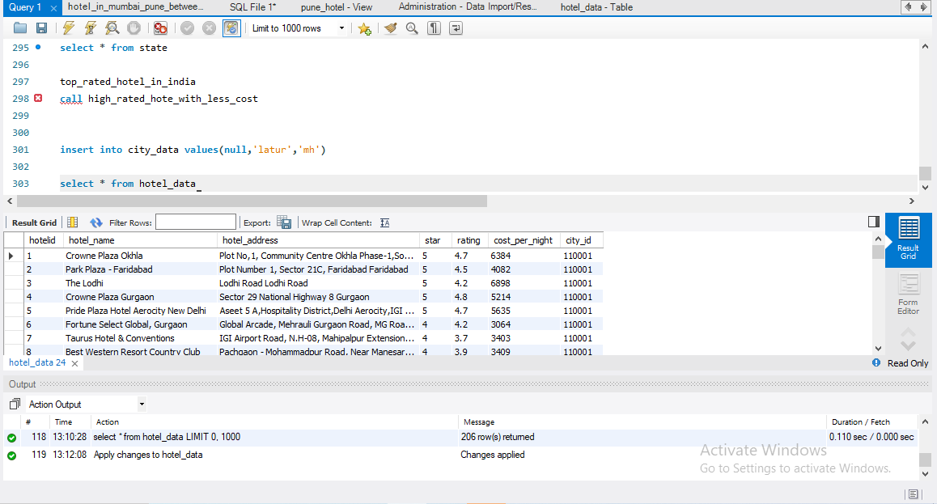

As you can see, the time taken to process the table is 0.110sec in this case over this table.

* Performance after applying indexing

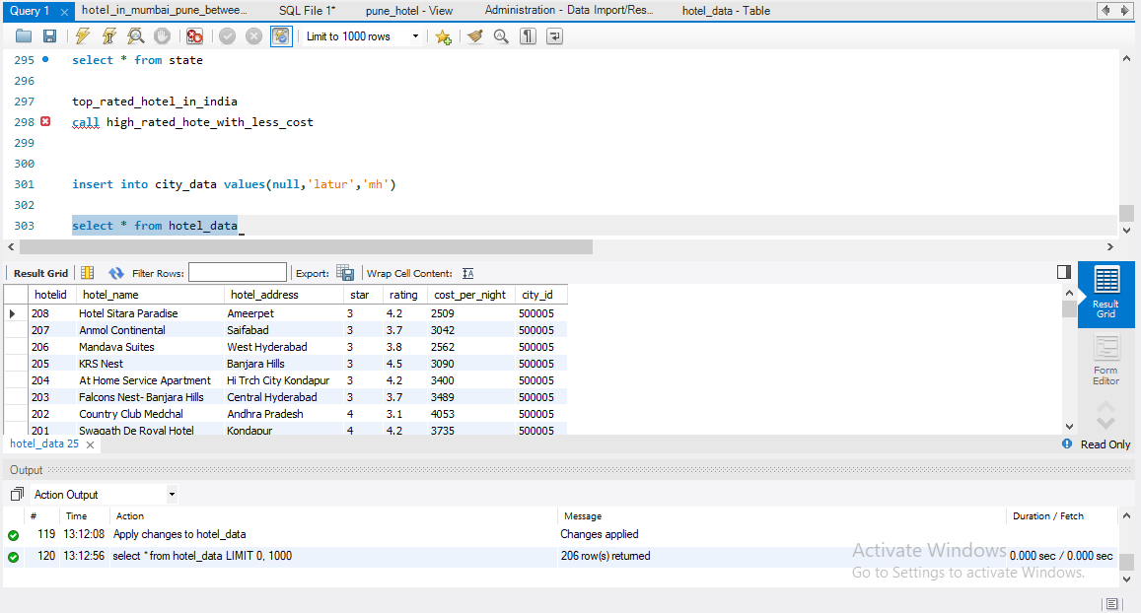

Now we can see performance how much improved after applying indexing as time takes to process is reduced to 0.000 sec.which is the main benefit of indexing it provides speed in performance.

* Indexes make search queries much faster.
* Indexes like primary key index and unique index help to avoid duplicate row data.

**Output reports generated upon database**

* which is the hotel uses bus as a transport and having price above 6000 which is the hotel uses bus as a transport and having price above 6000

select hotel_name,city_name, transport_mode_name ,cost_per_night

from hotels inner JOIN transport on hotels.transport_id= transport.transportmode_id

where transport_mode_name="bus" AND cost_per_night>6000

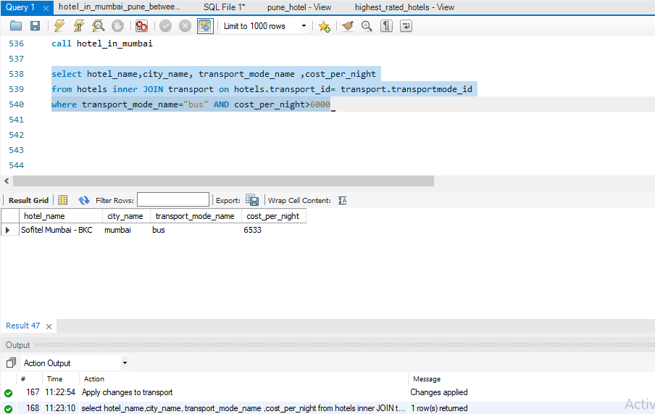

* which is the five star hotel of which state which has the five rating.

select hotel_name,star, rating, State_name

from hotels inner join state_code on hotels.state_id=state_code.State_id

where star=5 and rating=5

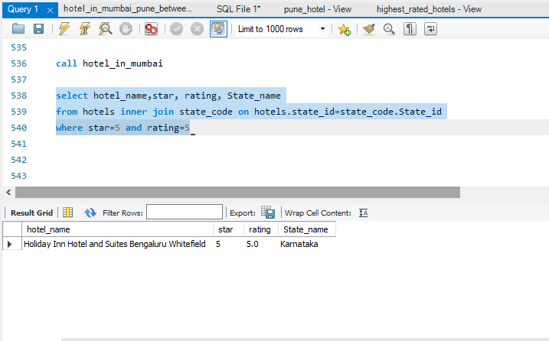

* what are count of 5 star hotel in delhi

select count(star) from hotels inner join state_code on hotels.state_id=state_code.State_id

where star=5 and State_name="Delhi"

* which are the hotels which have rating below 3 and using transport mode as car

select hotel_name,rating,transport_id

from hotels inner join transport on hotels.transport_id= transport.transportmode_id

where rating<3 and transport_mode_name="Car"

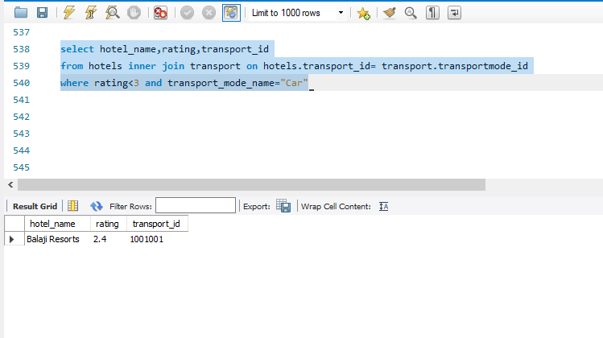

* how many hotel are there which has a price range between 5000 to 6000

select count(hotel_name) from hotels where cost_per_night BETWEEN 5000 and 6000

* which hotel is the cheapest hotel in the list which has highest rating

select hotel_name,city_name,cost_per_night,rating from hotels where rating>4.8 order by cost_per_night asc limit 1

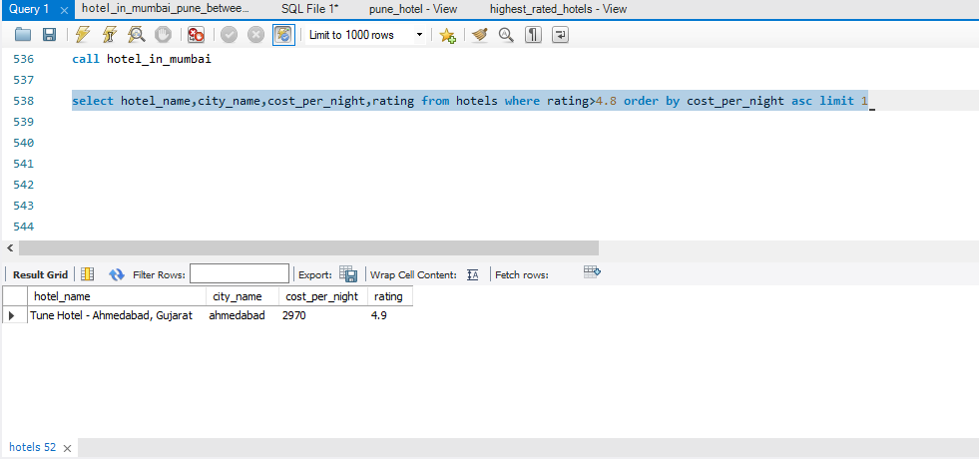

* which hotel is the cheapest hotel in the metro cities list and what is its rating and show its transport id

select hotel_name,rating,transport_id,cost_per_night from hotels order by cost_per_night asc limit 1

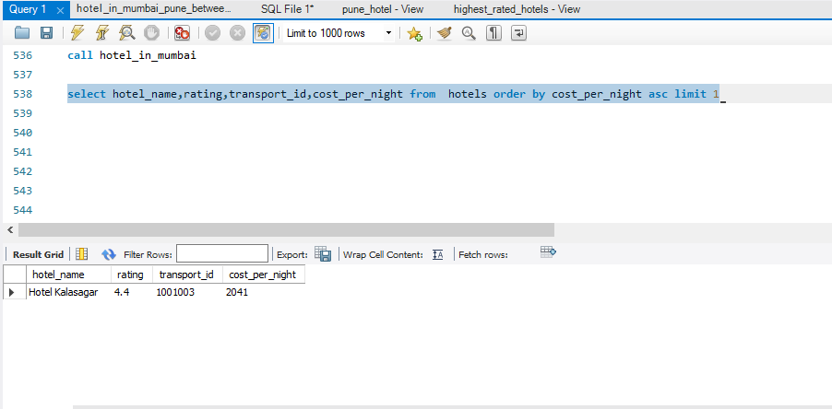

* show all the hotels which have rating between 3 to 3.5 only and arrange it in ascending order

SELECT hotelid ,hotel_name, city_name,rating

FROM hotels where rating BETWEEN 3 and 3.5 order by rating;

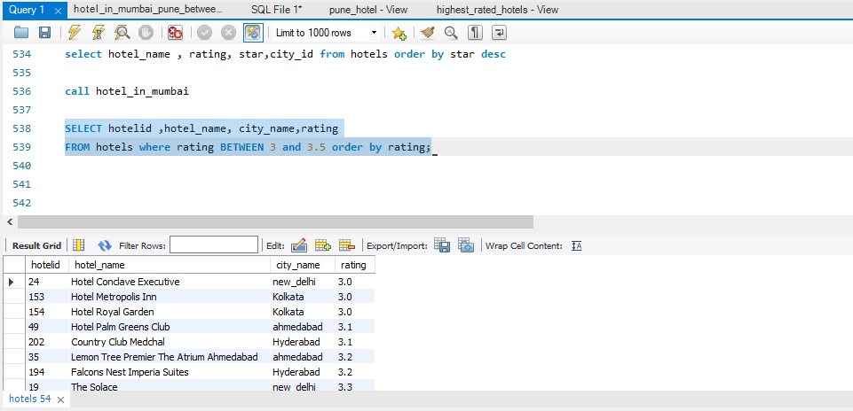

* Which are the hotels whose hotel name starting with lemon with their hotel id and state name

SELECT hotel_name,hotelid,State_name from hotels inner join state_code on hotels.state_id=state_code.State_id where hotel_name like "lemon %"

